NEXTAG COMPANY

CALVIN KLEIN - EXOTIC LIZARD AVIATOR WALLET

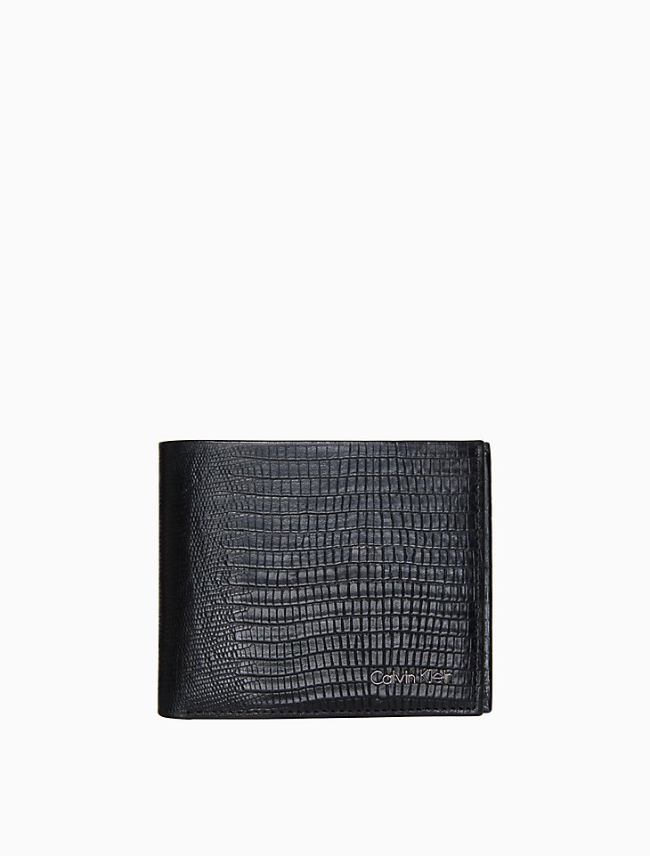

##### **Detail**

made with an exotic lizard textured faux leather, this aviator wallet features a bifold design, a logo on the front, interior slots and border topstitching.

* exotic lizard aviator wallet
* bifold design
* logo plaque
* interior bill slot + card slots
* topstitching + seaming details
* 4.6" wide x 3.8" tall x 1" deep

Style #: 47208773

##### **CARE & COMPOSITION**

* faux leather
* imported